
Qingdao Mike & Mary Hair Co., Ltd.

No.2, XiaoMaWan West Village, JiaoDong Town, JiaoZhou, 266317, Qingdao, China.
Tel: +86-532- 88261065 Fax:+86-532-88260078 Website: www.mikemary.cn
Email: mikemaryhair@gmail.com MSN: mikemaryhair@hotmail.com Yahoo: mikemaryhair@yahoo.cn

Lace Wigs Order Form
Order No.: Quantity: Date:
Name of Client: Company Name:
Type of Hair: [ ] Indian Remy [ ] Chinese remy [ ] Others
Hair Texture & Curl: [ ] As picture
Hair Length:
Hair Color: [ ] As picture
Hair Density: [ ] 80% [ ] 90% [ ] 100% [ ] 115% [ ] 130%
[ ] 140% [ ] 150% [ ] customized
Baby Hair: [ ] None [ ] Front Only [ ] Around Entire Perimeter
Baby Hair Type: [ ] None [ ] Straight [ ] Wavy [ ] Curly
Type of Knots: [ ] Single Knots [ ] Double Knots [ ] Bleached Knots [ ] Other Knots
Hair Parting: [ ] Free Style(flat back) [ ] Right Part [ ] Left Part [ ] Center Part

Cap Construction
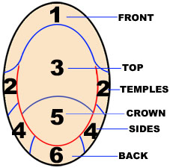  If you are getting high-lights please let me know the area that you want each color | Cap Design:  1.[ ] Lace Front Wigs(1-2-3 is lace, other area is stretch lace)  2.[ ] Full lace wigs  2-1[ ] With a little Stretch Lace From ear to ear with PU  2-2[ ] With a little Stretch Lace From ear to ear NO PU  2-3[ ] Without Stretch Lace.  3.[ ] Full thin Skin ,all head is thin skin.  4.[ ] thin skin around perimeter，lace around the head, with a little stretch lace from ear to ear  5.[ ] customized  Lace Color: [ ] dark brown [ ] brown [ ] light Brown  [ ] transparent [ ] Flesh  Lace Type: [ ] Swiss [ ] French
Cap Size
[ ] Large [ ] Medium [ ] Small [ ] Customized
Head Measurement Template
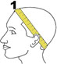 Circumference 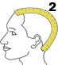 Forehead to Nape
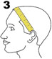 Ear to ear across front hairline 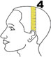 Ear to ear over top
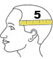 Temple to temple round back 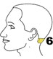 Nape of Neck

Size: 1 2 3 4 5 6 __ _
Friendship Reminding:
Please make sure that you make your head measurement in this way shown in the above pictures. Right measurement is very important for us to make right wig for you. If the measurement is not right, the lace wig will not work because we will exactly make the wig according to your measurement size.
We are not responsible for the wrong measurements.
Special Instruction

Lace Cap Reference
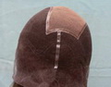  M01 | 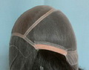  M02 | 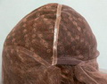  M03 | 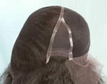  M04
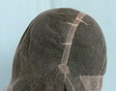  M05 | 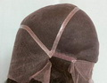  M06 | 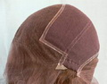  M07 | 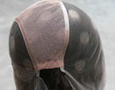  M08
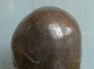
M09

